 

INFRASTRUCTURE APPLICATION REQUIREMENTS -  
DWH   
DataWareHouse Legacy

Version: 1.1

Date: 13-12-2023

Based on Template: UWV REQ – TEMPLATE 2.0docx

## Table of Contents

Table of Contents 2

Document purpose: 3

Relation to other documents 4

Content of the document 4

Document change history 4

1 Application Overview 5

1.1 Introduction 5

1.2 Scope of the desired change 5

1.3 Application use cases 5

1.4 Out of scope 5

2 Architecture 6

2.1 Conceptual 6

2.2 Context diagram 7

3 Functional Requirements 15

4 Non-Functional Requirements 16

4.1 Security & Compliance classifications 16

4.2 System and Software requirements 16

4.3 Performance requirements 19

4.4 Security requirements 19

4.5 Backup and Recovery 20

4.6 Disaster Recovery 20

Appendix: Legenda Context Diagram 21

## Document purpose:

What is the Requirement document and why?

The requirement document is a Word document owned and managed by UWV.

The template of the requirement document can be found at this link: [Joined Collaboration Platform](https://dxcportalgbr.sharepoint.com/sites/UWVJCP/Delivery/Infrastructure/Forms/AllItems.aspx?RootFolder=%2Fsites%2FUWVJCP%2FDelivery%2FInfrastructure%2F00%5FInstructies%20en%20Templates%20%2D%20HLD%20en%20Requirements%20management&FolderCTID=0x012000E2656A960112194C951E9D08878546D9&View=%7B325BC795%2D92C8%2D49C8%2D9509%2D5F65CBCD32A3%7D) If you cannot access the link, ask access to [jcp@uwv.nl](mailto:jcp@uwv.nl)

If a business division would like to :

1. implement a new CI (application)
2. modifiy an existing CI (for example an upgrade of a server, a new connection request, a new functionality, a new component, a new server, etc.)

Then the business division (using the template) should fill-in the requirements, which will be reviewed according to the “HLD Fabriek” process.

Special requests – as exceptions – could be handled outside the “HLD Fabriek” process.

Once the requirement document will be filled-in for a new/existing CI, the business division which owns the CI will become also the owner of the requirement document, also for future versions and changes.

Why the requirement document is important ?

1. The requirement document is a collection of wishes and requirements from the business division to the leverancier DXC.

The document contains requirements:

on hosting (hardware, software) level

on security en compliancy level

on network level (connections)

on functionality level (use cases)

on performance level

and it will be used by DXC to:

* Gain a general understanding of the application requirements
* Deliver the Infrastructure Application design (IA HLD): after the validation of the HLD by the UWV Technical Design autority (TDA) a “building permit”or “Bouwvergunning” is issued by the TDA. That is the starting point for projects realization phase. For more info on the TDA please turn to the ICT Services Lead Architect.

1. The requirement document is also important because it has a contractual relevance

Why the requirement document must be written in English ?

Because the Requirement document and the HLD are considered technical documents and DXC is a global company with employees from all over the world, thus English is the official language.

Name of this requirement document

The name of this requirement document = name of the application (CI).

A correct application name must be used, consistent with confipedia (use exact full name, case sensitive). Link to site: [Confipedia](https://samenwerken.sharepoint.uwv.nl/sites/ict/pm/config/basl%20html/index.html)

In case this document describes a cluster of applications, each application must be mentioned here separately

Contact:

If you have questions, feedbacks or remarks regarding this template, please contact ict.ior_applicatiehosting@uwv.nl

## Relation to other documents

The following documents may be relevant as context to this REQ:

* The Software Architecture Document (SAD). If available deliver the SAD as a separate document.
* The Project Start Architecture (PSA) document

Infrastructure Application design produced by DXC for related applications (interfaces)

## Content of the document

UWV has prepared this document in good faith and is based on the information gathered during the requirement determination phase with all parties involved; application vendors, UWV architects, developers and UWV functional management.

## Document change history

Please note:

For brand new applications: UWV needs to deliver to DXC a “major” version 1.0

For existing applications (already implemented in production for example) UWV needs to deliver to DXC a new, updated version of the requirement document.

|  |  |  |  |
| --- | --- | --- | --- |
| Version | Date | Author | Summary of Changes |
| 1.0 | 30-10-2023 | Luca Cheung | Creation of the requirements document v.1.0 based on HLD v1.2 |
| 1.1 | 13-12-2023 | U. Can | Adjusment based on v1.0 |
|  |  |  |  |

# Application Overview

## Introduction

DWH is not an application but a data integration and database infrastructure for the division GD DWH. All ETL programs are customer Oracle packages, procedures and shell scripts developed by UWV, no external party is involved for development.

Proprietary ETL software (MDT) MetaDataTool and (DoD) DatawarehouseOndemand (DWH2) and (OWB) Oracle Warehouse Builder (DWH3) is used to generate PL-SQL packages.

There is no OTOD environment, all environments (production, acceptance, test (includes development database) will be hosted on DXC managed servers.

TAB will be performed by UWV instead of DXC according to theso called C+ scenario, which is also applicable for DIM Infosphere and DWH-DMAP.

## Scope of the desired change

Please insert a clear description of the desired change.

## Application use cases

Application use cases are not defined, not applicable, or unknown to DXC.

## Out of scope

* DWH Oracle Cloud Control (management server), this is moved to DIM Infosphere
* DWH Historical data, the solution is described in a separate document, storage details can befound in Appendix A of this HLD.
* Terminal Server for deployments, is part of DIM Infosphere
* All components that belong to the UWV Office Infrastructure such as workstations, web browsers are out of scope

# Architecture

## Conceptual

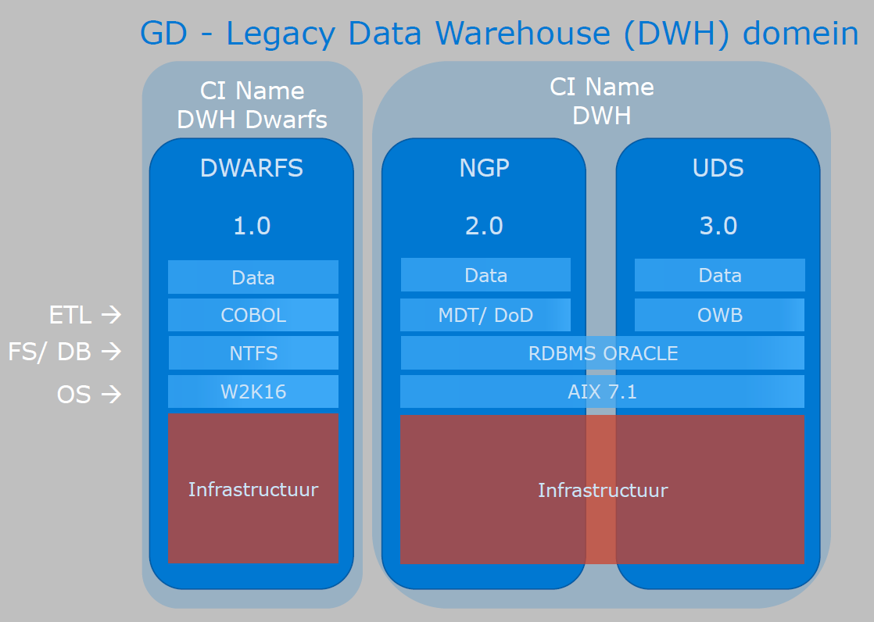

**DWH Key concepts:**

This paragraph specifies the key IT system level architectural concepts

* An AIX based Database server
* Oracle as the DBMS with:
  + MDT and DoD as ETL subsystems for DWH2
  + Oracle Warehouse Builder as a ETL subsystem for DWH 3
* A production environment
* An acceptance environment
* A test environment (includes development database, no infrastructure in the deployment environment)
* Database maintenance by UWV

## Context diagram

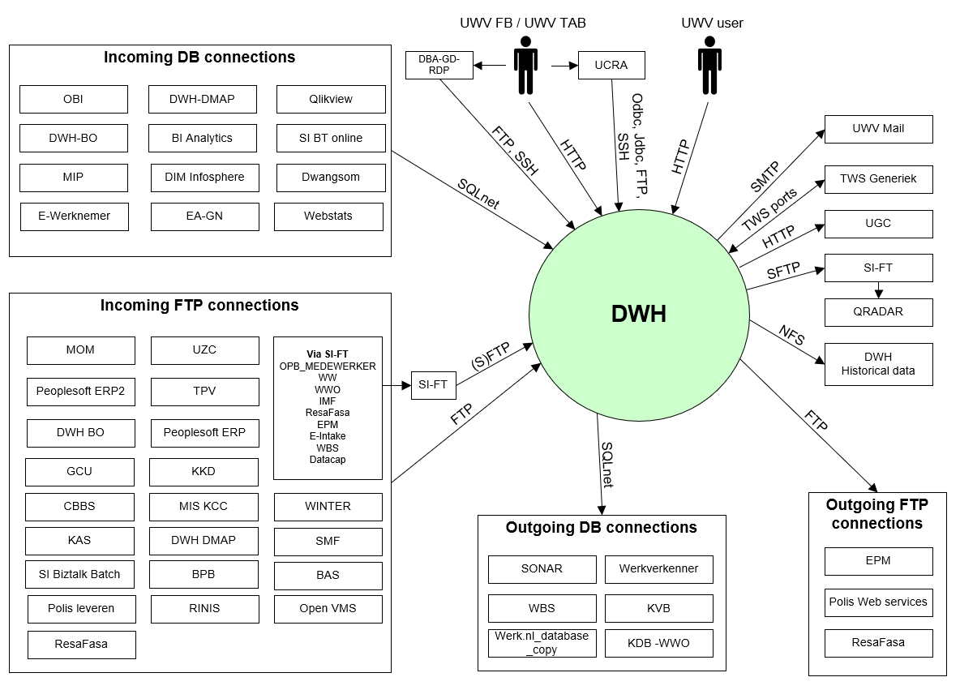

**Context diagram - DWH Deployment**

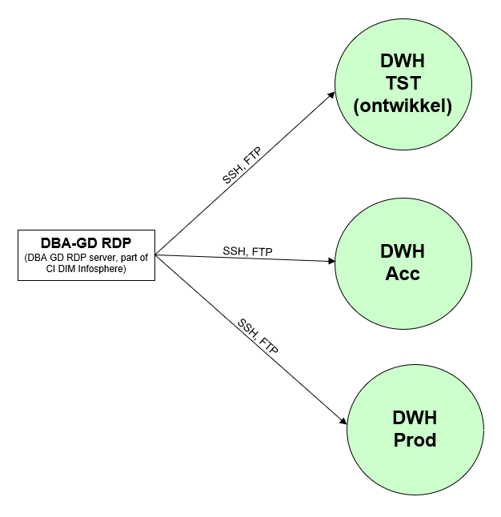

### External entities

#### Entity UWV FB / UWV TAB

|  |  |
| --- | --- |
| **Description** | 1. Functional management for MDT and DoD ETL applications are using a standard APEX webform for granting MDT/ DoD application role based acces (stored in Apex repository). 2. SQL Developers via UCRA and users who performs the ETL loading process and functional management of the application. The DWH functional managers are allowed) to exchange data with the DWH environment 3. DWH Deployments via DBA-GD-RDP (DBA-GD-RDP is only available in Production – DXC Application mgmt. zone) |
| **Protocol and Port** | 1. HTTP (8080) 2. Odbc/Jdbc (1526), FTP (20, 21, 22), SSH (22) 3. FTP (21), SSH (22) |
| **DC (Datacenter) connection** | 1. External 2. External 3. External |
| **Direction** | 1. Inbound 2. Inbound 3. Inbound |
| **Direct connection** | 1. Yes 2. No Via: UCRA 3. No Via: DBA-GD-RDP |
| **Security Controls** | Connection 1:  Authorisation method or authentication method: Apex DB account  Use certificates: No  Service account: No  Connection 2:  Authorisation method or authentication method: DB and AIX account  Use certificates: No  Service account: No  Other: Based on ABS (AD) role based acces in combination with equal Oracle DB role-based access.  Connection 3:  Authorisation method or authentication method: DB and AIX account  Use certificates: No  Service account: No  Other: Based on ABS (AD) role based acces in combination with equal Oracle DB role-based access. |
| **Number of users** | not specified |
| **Number of transactions** | not specified |
| **Frequency of transactions** | not specified |
| **Volume of data in transit** | not specified |

#### Entity UWV Users

|  |  |
| --- | --- |
| **Description** | DWH users that connect to the APEX web services for reading. |
| **Protocol and Port** | HTTP (8080) |
| **DC (Datacenter) connection** | External |
| **Direction** | Inbound |
| **Direct connection** | Yes |
| **Security Controls** | Authorisation method or authentication method: Apex DB account  Use certificates: No  Service account: No  Other: ABS (AD) with equal Oracle DB role based acess. |
| **Number of users** | not specified |
| **Number of transactions** | not specified |
| **Frequency of transactions** | not specified |
| **Volume of data in transit** | not specified |

#### Entity Incoming DB Connections

|  |  |
| --- | --- |
| **Description** | DWH Database access from UWV Business applications:  Is currently applicable for the following :  OBI, DWH-BO, MIP, e-Werknemer, DWH-DMAP, BI Analytics, DIM Infosphere, EA-GN, Qlikview, SI BT online, Dwangsom, Webstats |
| **Protocol and Port** | SQLnet (1526) |
| **DC (Datacenter) connection** | Internal |
| **Direction** | Outbound |
| **Direct connection** | Yes |
| **Security Controls** | Authorisation method or authentication method: DB account  Use certificates: No  Service account: No |
| **Number of users** | not specified |
| **Number of transactions** | not specified |
| **Frequency of transactions** | not specified |
| **Volume of data in transit** | not specified |

#### Entity Incoming FTP Connections

|  |  |
| --- | --- |
| **Description** | UWV Business applications that send files to DWH  Is currently applicable for the following :  GCU, CBBS, KAS, SI Biztalk Batch, MOM, Peoplesoft ERP2, DWH-BO, KKD, MIS KCC, DWH DMAP, BpB, UZC, TPV Peoplesoft ERP, WINTER, SMF, BAS, Open VMS, RINIS, Polis Leveren, ResaFAsa  The following application send the files via SI-FT:  OPB_MEDEWERKER, WW, WWO, IMF, ResaFasa, (Belastingsdienst via) EPM, E-Intake, WBS, Datacap |
| **Protocol and Port** | Direct connections: FTP (21)  Connections via SI-FTP: (S)FTP (21, 22) |
| **DC (Datacenter) connection** | Internal |
| **Direction** | Inbound |
| **Direct connection** | Some connections are direct, and some connections are via SI-FT, see the above description |
| **Security Controls** | Authorisation method or authentication method: DWH account  Use certificates: No  Service account: No |
| **Number of users** | not specified |
| **Number of transactions** | not specified |
| **Frequency of transactions** | not specified |
| **Volume of data in transit** | not specified |

#### Entity Ougoing DB Connections

|  |  |
| --- | --- |
| **Description** | DWH Database access to UWV Business applications:  Is currently applicable for the following :  SONAR, WBS, Werk.nl_database_copy, Werkverkenner, KVB, KDB-WWO |
| **Protocol and Port** | SQLnet (1526) |
| **DC (Datacenter) connection** | Internal |
| **Direction** | Outbound |
| **Direct connection** | Yes |
| **Security Controls** | Authorisation method or authentication method: DB account  Use certificates: No  Service account: No |
| **Number of users** | not specified |
| **Number of transactions** | not specified |
| **Frequency of transactions** | not specified |
| **Volume of data in transit** | not specified |

#### Entity Outgoing FTP Connections

|  |  |
| --- | --- |
| **Description** | UWV Business applications that DWH send files to  Mostly shared by ‘file-share’ delivery on the metioned UWV business applications domain  Is currently applicable for the following : EPM, Polis Web services, ResaFasa |
| **Protocol and Port** | FTP (21) |
| **DC (Datacenter) connection** | Internal |
| **Direction** | Outbound (connection initiated by the application) (mandatory field) |
| **Direct connection** | Yes |
| **Security Controls** | Authorisation method or authentication method: DWH account  Use certificates: No  Service account: No |
| **Number of users** | <Preferred if known otherwise “not specified”> |
| **Number of transactions** | <Preferred if known otherwise “not specified”> |
| **Frequency of transactions** | <Preferred if known otherwise “not specified”> |
| **Volume of data in transit** | <Preferred if known otherwise “not specified”> |

#### Entity UWV Mail

|  |  |
| --- | --- |
| **Description** | UWV mail relay services that sends outgoing mail to UWV FB |
| **Protocol and Port** | SMTP (25) |
| **DC (Datacenter) connection** | External |
| **Direction** | Outbound |
| **Direct connection** | Yes |
| **Security Controls** | Authorisation method or authentication method: None required  Use certificates: No  Service account: No  Other: Whitelisting, STARTTLS |
| **Number of users** | not specified |
| **Number of transactions** | not specified |
| **Frequency of transactions** | not specified |
| **Volume of data in transit** | not specified |

#### Entity TWS Generiek

|  |  |
| --- | --- |
| **Description** | TWS Generiek connection with DWH |
| **Protocol and Port** | Inbound: TCP (34243)  Outbound: TCP (31111, 31116) |
| **DC (Datacenter) connection** | Internal |
| **Direction** | Inbound and Outbound |
| **Direct connection** | Yes |
| **Security Controls** | Authorisation method or authentication method: None required  Use certificates: No  Service account: No |
| **Number of users** | not specified |
| **Number of transactions** | not specified |
| **Frequency of transactions** | not specified |
| **Volume of data in transit** | not specified |

#### Entity UGC

|  |  |
| --- | --- |
| **Description** | Call by SUAG (DWH) |
| **Protocol and Port** | HTTP (80) |
| **DC (Datacenter) connection** | Internal |
| **Direction** | Inbound and Outbound |
| **Direct connection** | Yes |
| **Security Controls** | Authorisation method or authentication method: User and Password  Use certificates: No  Service account: No |
| **Number of users** | not specified |
| **Number of transactions** | not specified |
| **Frequency of transactions** | not specified |
| **Volume of data in transit** | not specified |

#### Entity QRADAR

|  |  |
| --- | --- |
| **Description** | Application logs for QRADAR  Application logs are applicable for all environments, this requires an additonal connection from DWH Test to SI-FT Prod |
| **Protocol and Port** | SFTP (22) |
| **DC (Datacenter) connection** | Internal |
| **Direction** | Outbound |
| **Direct connection** | No  Via: SI-FT |
| **Security Controls** | Authorisation method or authentication method: DWH account  Use certificates: No  Service account: No |
| **Number of users** | not specified |
| **Number of transactions** | not specified |
| **Frequency of transactions** | not specified |
| **Volume of data in transit** | not specified |

#### Entity DWH Historical Data

|  |  |
| --- | --- |
| **Description** | DWH Historical Data solution – DWH requires the possibility to backup historical data and restore on request. Backup / Restore of this data is performed by UWV (only available in Production) |
| **Protocol and Port** | NFS (22) |
| **DC (Datacenter) connection** | Internal |
| **Direction** | Outbound |
| **Direct connection** | Yes |
| **Security Controls** | Authorisation method or authentication method: NFS mountpoints  Use certificates: No  Service account: No |
| **Number of users** | not specified |
| **Number of transactions** | not specified |
| **Frequency of transactions** | not specified |
| **Volume of data in transit** | not specified |

# Functional Requirements

No functional requirements specified.

# Non-Functional Requirements

## Security & Compliance classifications

Repository used is: 2022 UWV-brede Risico Applicatie Lijst v1.0

[BIV classificatie 2.0](https://samenwerken.sharepoint.uwv.nl/sites/DWU/ConcernICT/IBenP/CISO-Office/SiteAssets/SitePages/4.%25)

|  |  |
| --- | --- |
| **Application** | DWH |
| **Owner** | Gegevensdiensten |
| **Availability (Beschikbaarheid)** | 2(Hoog) |
| **Integrity (Integriteit)** | 2(hoog) |
| **Confidentiality (Vertrouwelijkheid)** | 3(Strikt vertrouwelijk) |
| **Type of information /Data Classification** | Personal information of clients |

### Applicable security and compliance frameworks

|  |  |  |
| --- | --- | --- |
| Security & Compliance Framework | Applicable | Comments |
| BIO | Yes (applicable) |  |
| AVG / GDPR | Yes (applicable) |  |
| DIGID | No (not applicable) |  |
| SUWI | No |  |
| Additional frameworks | SSD |  |

## System and Software requirements

### Private Cloud system

#### System (Operating system (OS))

| **Server(type)** | **Operating System** | **Version** |
| --- | --- | --- |
|  | AIX | 7.2 |
|  |  |  |

#### System capacity forecast (volumetrics)

| **Server(type)** | **vCPU** | **RAM (GB)** | **Data Storage (GB)**  Data storage size for the OS is fixed |
| --- | --- | --- | --- |
| Production | 11 | 144 | 22+4 TB |
| Acceptance | 4 | 144 | 18+2 TB |
| Test | 5 | 120 | 8+2TB |
|  |  |  |  |

#### Availability

|  |  |  |
| --- | --- | --- |
| **Environment** | **DXC Application Target**  (Availability (service hours) = SLA) | **Infra Target* (only for Application target 98%)**  (Availability (service hours) = SLA) |
| Production | n/a* | 98% (7x24) = Bronze |
| Acceptance | n/a* | 98% (7x24) = Bronze |
| Test | n/a* | 98% (7x24) = Bronze |

*TAB is performed by UWV instead of DXC

#### Storage replication

|  |  |
| --- | --- |
| **Environment** | **Storage Replication** |
| Production | Non-replicated storage |
| Acceptance | Non-replicated storage |
| Test | Non-replicated storage |

#### Scalability

No scalability limitatons for the applications are specified.

| **Server(type)** | **Scalability type** | **Additional Comments** |
| --- | --- | --- |
| <example: server 1> | Kies een item. |  |
| <example: server 2> | Kies een item. |  |

In case of infra load balancer, specify requirements:

Load balancer infra requirements

|  |  |
| --- | --- |
| **Application Layer** | HTTP (L7) |
| **Application Port(s)** | 80 |
| **Algorithm** | Least Connections (default) |
| **Stickiness/Persistence** | None |
| **Health monitor type** | System-HTTP |

Please note: the default algorithm is: Least connections. Do not deviate from this, unless theres is a specific reason.

#### Software (Licenses)

| **Server(type)** | **Software product / component** | **Version** |
| --- | --- | --- |
| <example:Database server 1> | Oracle database server | 11.2.0.4 |
|  | Oracle Automatic Storage Manager ASM | 19c |
|  | Oracle Pack: Diagnostics Pack |  |
|  | Oracle Pack: Tuning Pack |  |
|  | Oracle REST services | 20.2.1 |
|  | Oracle Application Express (APEX) | 4.2.3 |
|  | IBM Workload scheduler Fault Tolerant Agent | 9.3 FP2 |
|  | Oracle Warehouse Builder standalone | 11.2.0.4 |
|  | OWB client (onderdeel van OWB) | 11g |
|  | Oracle Workflow (onderdeel van OWB) | 2.6.4 |
|  | Oracle Enterprise ETL option (paid option of OWB) | 11.2 |

#### System management

Not applicale.

#### Additional application related infra requirements

|  |  |
| --- | --- |
| **Requirements** | **Status** |
| Use STARTTLS option for UWV mail1 | Yes |
| Is Microsoft DTC used for inflight transactions2 | Not applicable |
| Mention other relevant requirements | Not applicale |

Please note:

1 UWV mail (The internal KPN mailrelay's for UWV (uwvmailrelay.voorzieningen.uwv.nl, prt 25) is equipped with the STARTTLS option.

This means that every application server can now send the SMTP messages encrypted if desired. STARTTLS is based on negotiation. TLS is not mandatory but is preferred. Mail clients that do not want or cannot use TLS can continue to send mail.  The TLS version used is TLS V1.2. To enable TLS, systems must be provided with Digicert's root and intermediate certificates. This is a public CA that appears in all common certificate stores.

2 In case SQL AOAG (Always On Availability Groups) is used, then MSDTC (Microsoft Distribuited Transaction Coordinator) needs to be configured as a cluster service)

#### DXC TAB requirements

Not applicale, TAB performed by UWV.

|  |  |
| --- | --- |
| **Category** | **Description** |
| 1. Deployment method | Kies een item. |
| 1. Deployment permissions |  |
| 1. Application Monitoring |  |
| 1. Other TAB applicable requirement |  |

## Performance requirements

## Security requirements

Because UWV performs TAB, UWV requires access to all DWH

environments. Special rights are required. (This does not apply to the UCRA environment).

• DWH infrastructure management / DBA role: not more than 2 persons. They need access to all DWH environments including A&P.

• Production managers. 6-8 persons. They need operational access to P for running and monitoring the ETL Data Feed processes. These managers need access to P environment to run installer script/wizard and refine pl/sql code to create or update production ETL process. This Production Access is due to the mostly manual ´enrichment process´.

• Developers, designers. Approx. 15-20 persons. They need access to O, T&Q and via regular access control also A.

• DWH Process managers, approx. 10-12 persons. They make information products in Q environment. Need access to Q and assist during Acceptance.

• For Production there are more than 100 ftp users/passwords on DWH. In order to avoid having to change the passwords at the source application side, the passwords from DWH at CMO must be transferred to DWH DXC (This is for Acceptance and Prod). (The CMO passwords are very weak, this is a deviation documented in 5.7)

Note: Q=Query database, is hosted on the Production server together with the P database

### System logging retention time

No specific system logging requirements are applicable

## Backup and Recovery

|  |  |  |
| --- | --- | --- |
|  | **Default** | **Deviation (when applicable)** |
| Backup | standard backup | Database archivelog backups/purges every 30 minutes |
| Restore | no specific restore order |  |
| Dependency | no dependencies |  |

## Disaster Recovery

No specific disaster recovery requirements applicable.

# Appendix: Legenda Context Diagram

